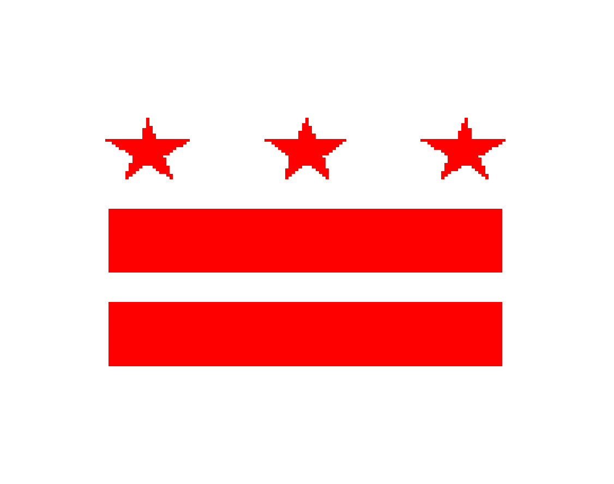
GOVERNMENT OF THE DISTRICT OF COLUMBIA
EXECUTIVE OFFICE OF THE MAYOR

OFFICE ON LATINO AFFAIRS

Executive Office of Mayor Muriel Bowser
Frank D. Reeves Center-2000-14th St NW., Second Floor (Suite 206) Washington, DC 20009
Main Office: 202-671-2825
Fax: 202-673-4557
www.ola.dc.gov

Minutes

Latino Community Development
Jackie Reyes, Johnny S. Garcia, Jonas Minino, Dr. Angelo Gómez, Angelique Sina
Commission Meeting
December 16, 2016
6:40 - 6:45pm

6:42 Conference call was established to accommodate commissioners who couldn’t attend the meeting in person

6:44 Jackie Reyes took attendance of commissioners present at the meeting. Only four commissioners answered present to the attendance call: Johnny S. Garcia, Jonas Minino, Dr. Angelo Gómez and Angelique Sina.

6:44 Johnny S. Garcia proposed to postpone the December meeting until the commission’s next meeting time in January due to the lack of quorum. All commissioners in attendance agreed.

6:45 Meeting was adjourned.

